MODEL SUPPLEMENT

Speakers may plausibly have preferences related to both baseline (i.e. cost of production) and context-specific aspects of production. We therefore also consider two models that incorporate unequal biases (costs) to produce each utterance type.

**Succeed/fail, with utterance costs (pSFC):**, This is constructed by multiplying the prior (context-insensitive) probability of each utterance by the (context sensative) probability under the succeed/fail model:

(10)

$$p_{SFC}\left(d | e,E\right)=\frac{{p_{NP}\left(d\right)*p}_{SF}\left(d | e,E\right)}{\sum_{d^{'}∈D}{{p_{NP}\left(d^{'}\right)*p}_{SF}\left(d' | e,E\right)}}$$

(Note that in this kind of model, it would also be possible to calculate the relative weight given to cost and informativity that best fits the dataset;

**Rational speaker, with utterance costs (*pRSC*):** Exactly in parallel, we can update the RSA-based model to also consider the context-independent preferences the speaker has to produce each utterance:

(11)

$$p_{RSC}\left(d | e,E\right)=\frac{{p_{CM}\left(d\right)*p}_{RS}\left(d | e,E\right)}{\sum_{d^{'}∈D}{{p_{CM}\left(d^{'}\right)*p}_{RS}\left(d' | e,E\right)}}$$

The Succeed/Fail-with-cost model shows a closer fit to the data than the base version, that are better still (r(36) = 0.81), but the closest fit to the human data was again found with the baseline-adjusted rational speaker model (r(36) = 0.89).

In an exploratory analysis, we asked why it is that correlation between human data and the Succeed/Fail with cost model is as high is it is: as can be seen in the plots below (Figure 4), this appears to be due to a Simpson's paradox effect (Blyth, 1972), whereby the global fit to the data (shown in gray) results from the high (but uncorrelated) rates at which both the model and the human participants produce verbs.

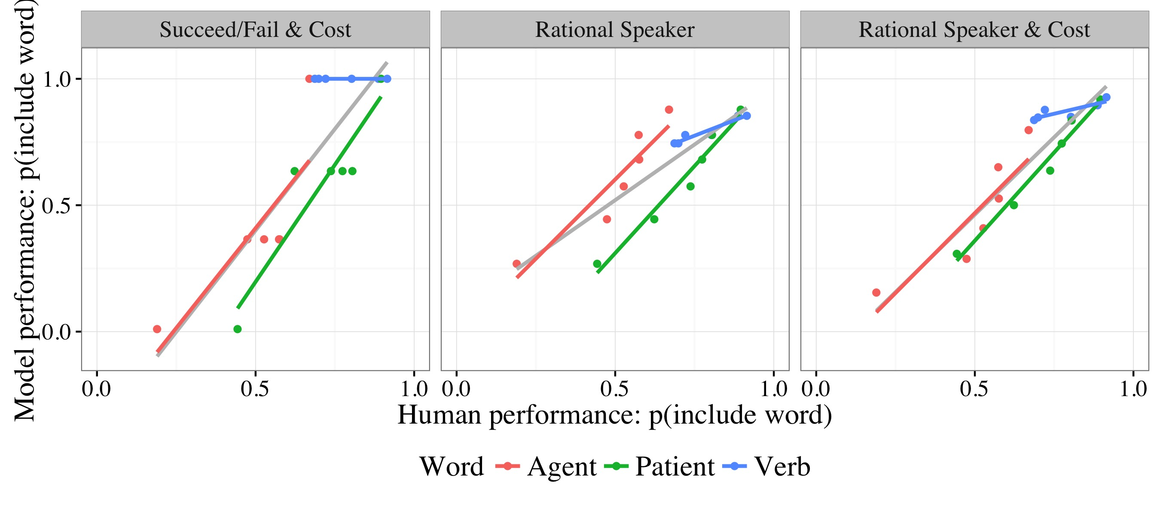Figure 4: Global (gray) and individual-word correlations between the three best models and human data, showing Simpson's paradox effects for the Succeed/Fail model and close fits to the data for all words in both Rational Speaker models.